**Manual For Fan Fixtures**

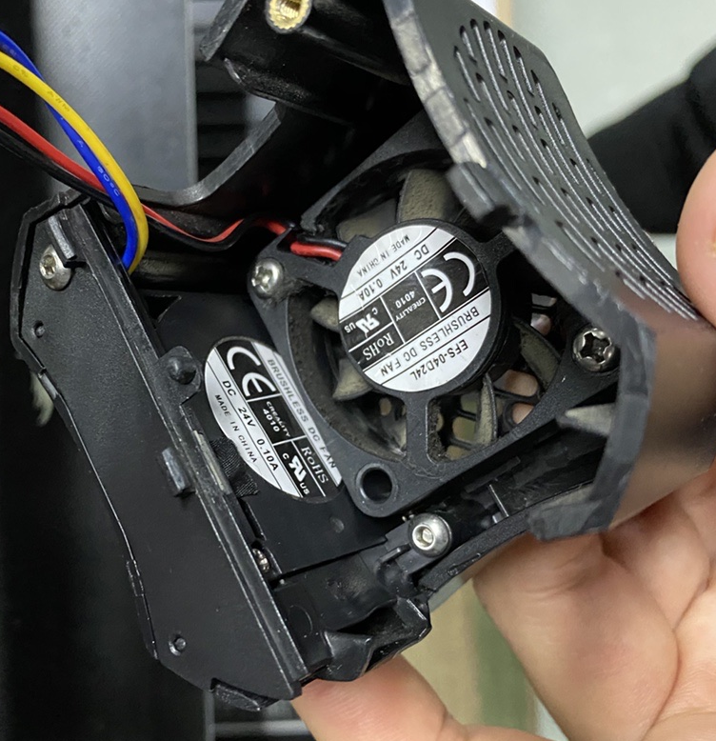

**0**

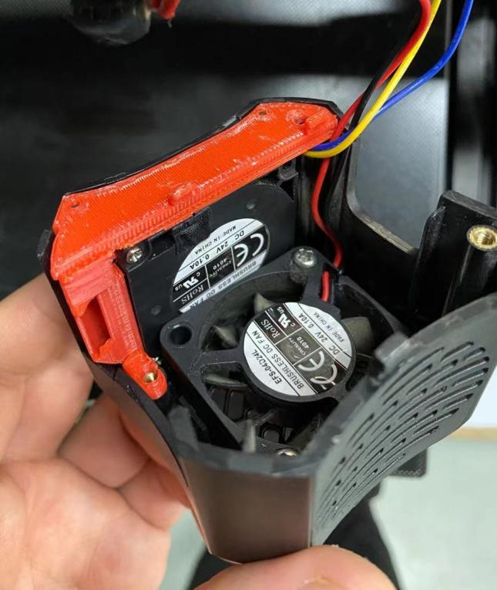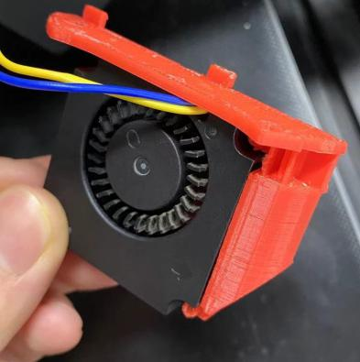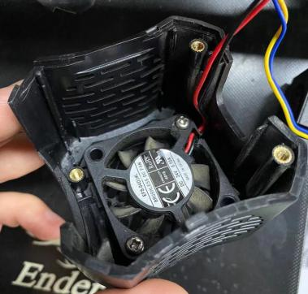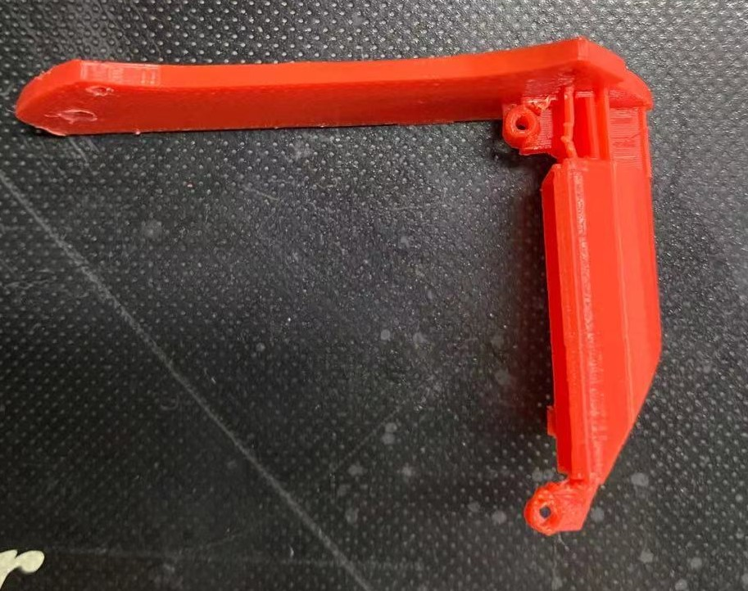

**Manual:**

**Step1: Remove the original Part 0 from the assembly.**

**Step2: Screw the Part 1 into the Part 2.**

**Step3: Screw the Part 1 and Part 2 together into the Part 3.**

**Then assembly the cooling system into the 3D printer, and enjoy the printing.**

**1**

**3**

**2**

**3**

**2**

**1**